Bahria University,

Karachi Campus



LAB EXPERIMENT NO.

___12__

LIST OF TASKS

|  |  |
| --- | --- |
| TASK NO | OBJECTIVE |
| **01** | Configure OSPF on the following network and show all necessary configuration steps for each router. |
|  |  |
|  |  |
|  |  |

Submitted On

20-12-2023

(Date: DD/MM/YY)

**Question 01:** Configure OSPF on the following network and show all necessary configuration steps for each router.

**Solution:**

**Router 1 Configuration:**

**Router 2 Configuration**

**Ping From PC 1 to PC 2**

**Ping From PC 2 to PC 1**

**Question 02:** Configure OSPF on the following network and show all necessary configuration steps for each router.

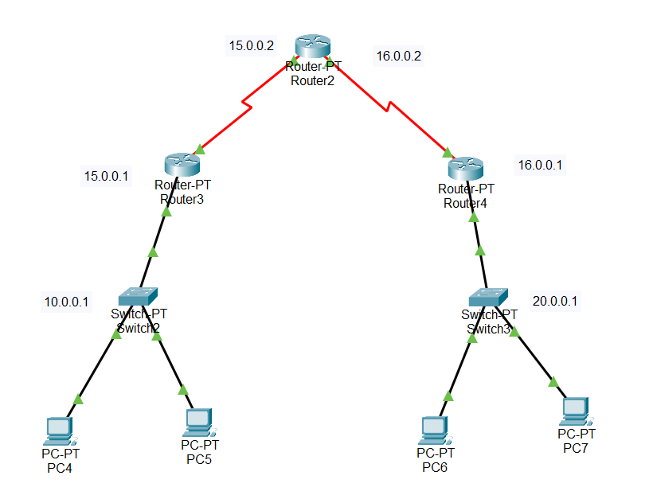

**Router 2 OSPF Configuration**

**Router 3 OSPF Configuration**

**Router 3 DHCP Configuration**

**Router 4 OSPF Configuration**



**Router 4 DHCP Configuration**

**